SUPPLY CHAIN DELIVERY PERFORMANCE ANALYSIS AND LATE DELIVERY RISK PREDICTION

Title: Supply Chain Delivery Performance Analysis
Prepared By: Rupjit Das
Tools Used: Python, Pandas, NumPy, Matplotlib, Seaborn, Scikit-Learn
Dataset: DataCo Supply Chain Dataset

Executive Summary
This project analyzes delivery performance within a supply chain environment using the DataCo Supply Chain dataset. The objective was to evaluate delivery efficiency, identify patterns behind delayed deliveries, and develop a machine learning model capable of predicting late delivery risk.
The analysis focused on delivery status, shipping duration, shipping modes, geographic performance, delivery trends, and delay distributions. In addition to descriptive analytics, a Random Forest classification model was developed to predict whether an order is likely to experience delivery delays.
The results provide operational insights that can help logistics managers improve service reliability, reduce delays, and proactively manage high-risk shipments.

Business Problem
Timely delivery is one of the most important factors affecting customer satisfaction and operational efficiency.
Delayed shipments can result in:
• Customer dissatisfaction
• Increased logistics costs
• Reduced operational performance
• Poor supply chain reliability
Organizations require a data-driven approach to understand delivery behavior and predict delivery risks before they occur.

Project Objectives
The objectives of this project are:
• Analyze overall delivery performance.
• Measure on-time and delayed deliveries.
• Compare actual shipping duration with scheduled shipping duration.
• Evaluate delivery performance by shipping mode.
• Identify regions and countries with higher delivery risks.
• Analyze monthly delivery trends.
• Build a machine learning model to predict late delivery risk.

Dataset Overview
Dataset Name: DataCo Supply Chain Dataset
Total Records: 180,519 Orders
Analysis Scope: Delivery Performance Analysis
Key Variables:
• Delivery Status
• Late_delivery_risk
• Days for shipping (real)
• Days for shipment (scheduled)
• Shipping Mode
• Order Region
• Order Country
• order date (DateOrders)
Derived Variables:
• Delay_Days
• Delay_Level
• Order Month

Executive KPI Dashboard
3.50
Average Shipping Daystotal_orders = len(delivery_df)
on_time_rate = ((delivery_df['Delay_Days'] <= 0).mean()* 100)
late_rate = ((delivery_df['Delay_Days'] > 0).mean()* 100)
avg_shipping_days = (delivery_df['Days for shipping (real)'].mean())

print(f"Total Orders : {total_orders:,}")
print(f"On-Time Delivery Rate : {on_time_rate:.2f}%")
print(f"Late Delivery Rate : {late_rate:.2f}%")
print(f"Average Shipping Days : {avg_shipping_days:.2f}")
57.28%
Late Delivery Rate
42.72%
On-Time Delivery Rate
180,519
Total Orders

Interpretation:
The KPI dashboard provides a high-level overview of supply chain delivery performance. These metrics help management quickly evaluate delivery efficiency and identify potential operational concerns.

Delivery Status Distribution
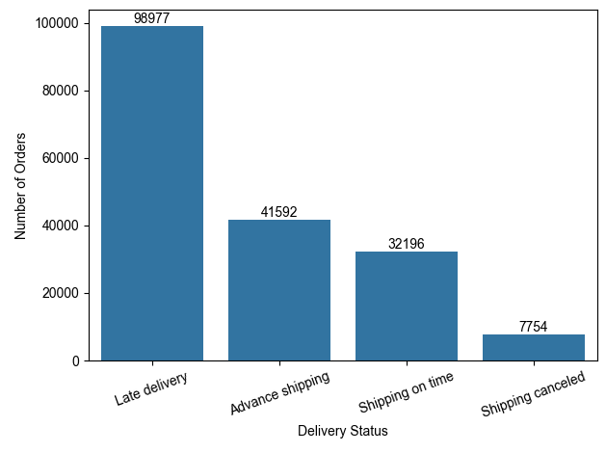Objective: To understand the overall distribution of delivery outcomes.
Observation: Late Delivery is the most common delivery status with 98,977 orders, followed by Advance Shipping (41,592) and Shipping On Time (32,196). Shipping Canceled has the lowest count (7,754).
Analysis: The large number of late deliveries indicates that meeting scheduled delivery timelines is a major challenge within the supply chain.
Business Impact: Frequent delivery delays can reduce customer satisfaction and increase operational costs.
Recommendation: Focus on identifying the root causes of delivery delays and improving logistics planning to increase on-time deliveries.

Late Delivery Risk Distribution
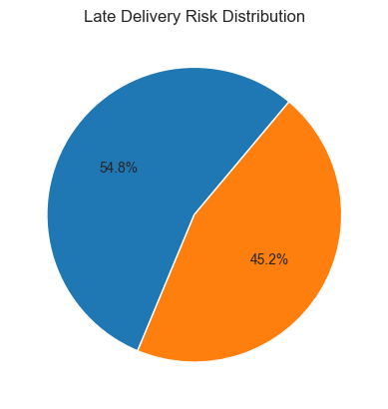
Objective: To evaluate the percentage of deliveries exposed to delay risk.
Observation: The chart shows that 54.8% of orders are at risk of late delivery, while 45.2% are not at risk.
Analysis: More than half of all orders fall into the late-delivery-risk category, indicating that delivery delays are a common issue within the supply chain.
Business Impact: A high late-delivery risk can negatively affect customer satisfaction, increase operational costs, and reduce overall service reliability.
Recommendation: Implement proactive monitoring and predictive analytics to identify high-risk shipments and take corrective actions before delays occur.

Actual vs Scheduled Shipping Days
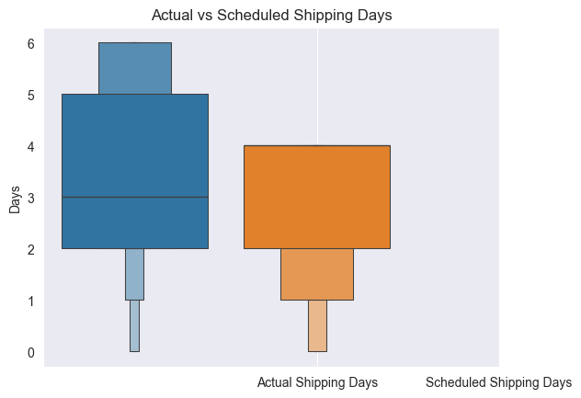Objective: To compare planned shipping duration with actual delivery duration.
Observation: The boxplot shows that actual shipping days are generally higher and more variable than scheduled shipping days. The median actual shipping time is slightly greater than the median scheduled shipping time.
Analysis: The difference between actual and scheduled shipping durations indicates that many deliveries take longer than originally planned, contributing to delivery delays.
Business Impact: Longer actual shipping times can reduce customer satisfaction and affect overall supply chain efficiency.
Recommendation: Review transportation and fulfillment processes to reduce the gap between planned and actual shipping times.

Average Delay by Shipping Mode
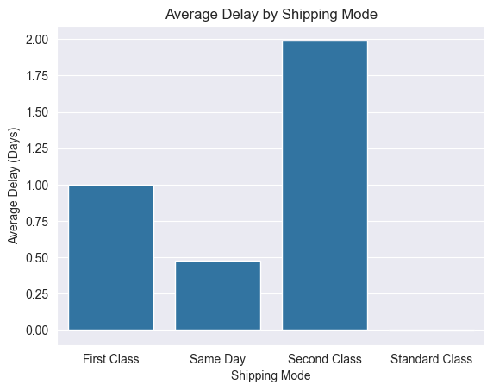
Objective: To identify shipping methods experiencing the highest delivery delays.
Observation: Second Class has the highest average delay (approximately 2 days), followed by First Class (1 day) and Same Day (0.5 days). Standard Class shows almost no delay.
Analysis: Delivery performance varies across shipping modes, with Second Class shipments experiencing the greatest delays compared to other methods.
Business Impact: Higher delays in specific shipping modes can reduce customer satisfaction and affect delivery reliability.
Recommendation: Investigate the operational processes of Second Class shipments and implement measures to reduce delivery delays.

Late Delivery Rate by Shipping Mode
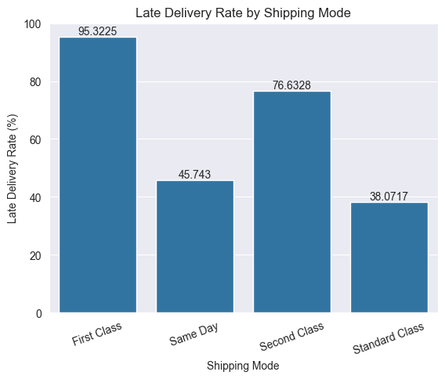
Objective: To evaluate delivery reliability across shipping methods.
Observation: First Class has the highest late delivery rate at 95.3%, followed by Second Class at 76.6%. Same Day (45.7%) and Standard Class (38.1%) have comparatively lower late delivery rates.
Analysis: The results indicate that delivery reliability varies significantly across shipping modes. First Class and Second Class shipments are more likely to experience delays than Same Day and Standard Class.
Business Impact: Higher late delivery rates can negatively impact customer satisfaction and reduce trust in premium shipping services.
Recommendation: Investigate the operational challenges affecting First Class and Second Class deliveries and implement corrective measures to improve their performance.

Delivery Performance by Region
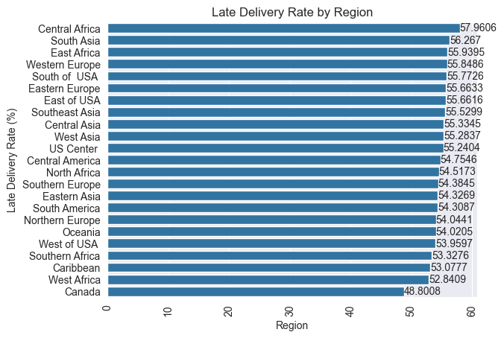
Objective: To compare delivery performance across geographic regions.
Observation: Central Africa records the highest late delivery rate (57.96%), followed by South Asia (56.27%) and East Africa (55.94%). Canada has the lowest late delivery rate (48.80%).
Analysis: Late delivery rates are relatively high across all regions, ranging from approximately 49% to 58%. However, regions such as Central Africa and South Asia experience slightly higher delivery risks.
Business Impact: Regions with higher late delivery rates may face greater customer dissatisfaction and operational challenges, affecting overall supply chain performance.
Recommendation: Focus on improving logistics operations in high-risk regions and investigate factors contributing to delivery delays.

Delivery Performance by Country
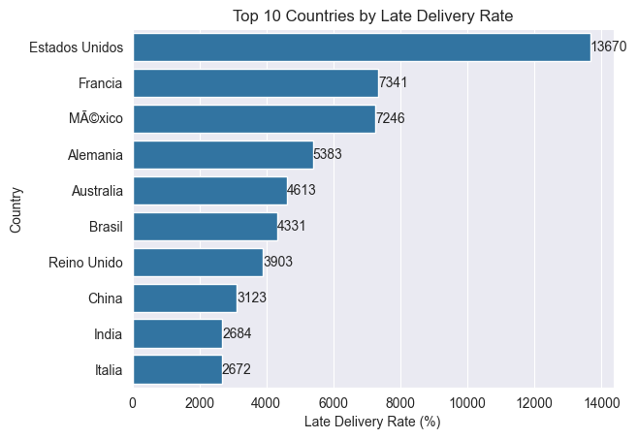Objective: To identify countries contributing most significantly to delivery delays.
Observation: The United States records the highest number of late deliveries (13,670), followed by France (7,341) and Mexico (7,246). India and Italy have comparatively lower late delivery counts.
Analysis: A significant portion of delayed deliveries is concentrated in a few countries, particularly the United States. This may be influenced by higher order volumes, transportation complexity, or operational inefficiencies in these markets.
Business Impact: Countries with a large number of delayed deliveries can significantly impact overall supply chain performance and customer satisfaction.
Recommendation: Prioritize logistics improvements and delivery monitoring in countries with the highest number of delayed shipments.

Monthly Delivery Trend
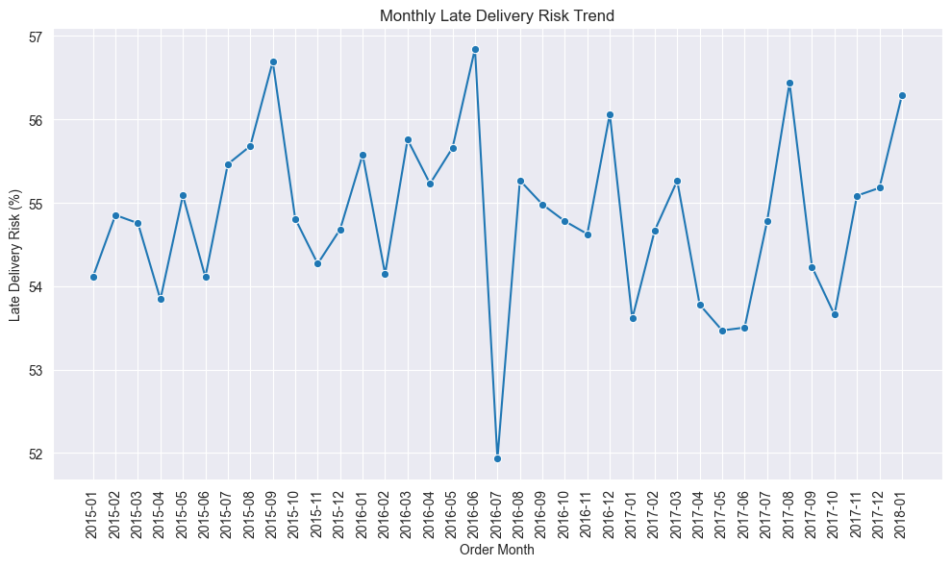Objective: To analyze changes in delivery performance over time.
Observation: The late delivery risk remains relatively stable throughout the period, fluctuating between 52% and 57%. A noticeable drop occurs around July 2016, while peaks are observed in several months including late 2015, mid-2016, and late 2017.
Analysis: Although there are short-term fluctuations, the overall late delivery risk remains consistently high over time. This indicates that delivery delays are a persistent issue rather than isolated incidents.
Business Impact: Consistently high delivery risk can affect customer satisfaction and increase operational costs if not addressed.
Recommendation: Implement continuous monitoring of delivery performance and investigate the factors responsible for recurring peaks in late delivery risk.

Delivery Delay Distribution
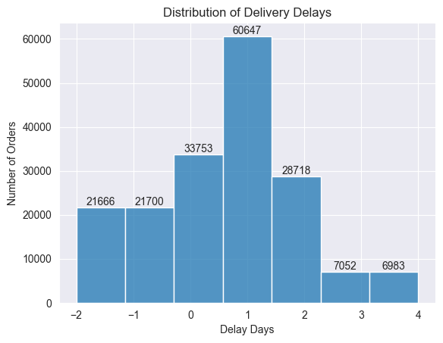Objective: To understand how delivery delays are distributed across all shipments.
Observation: Most orders are concentrated between 0 and 2 delay days, with 1-day delays being the most common. A smaller number of orders experience longer delays of 3–4 days, while some orders are delivered earlier than scheduled (negative delay days).
Analysis: The distribution indicates that most delivery delays are relatively short; however, delayed shipments occur frequently throughout the supply chain.
Business Impact: Even small delays can impact customer satisfaction when they occur consistently across a large number of orders.
Recommendation: Focus on reducing frequent 1–2 day delays through better scheduling, inventory planning, and transportation management.

Region × Shipping Mode Heatmap
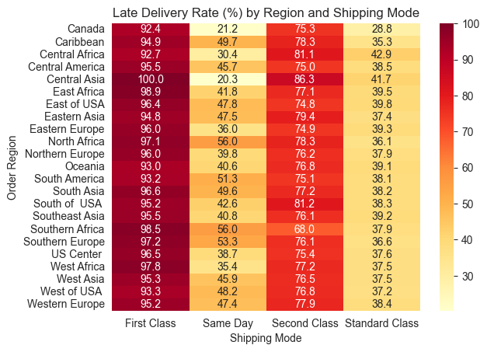
Objective: To identify combinations of regions and shipping methods associated with the highest delivery risk.
Observation: First Class consistently shows the highest late delivery rates across almost all regions, often exceeding 90%. In contrast, Standard Class records the lowest late delivery rates, generally between 30% and 43%.
Analysis: The heatmap reveals that shipping mode has a stronger impact on delivery performance than geographic region. First Class and Second Class shipments experience significantly higher delay rates, while Standard Class performs more consistently across regions.
Business Impact: High delay rates in premium shipping services can negatively affect customer trust and increase service recovery costs.
Recommendation: Review operational processes for First Class and Second Class shipments and adopt best practices from Standard Class operations to improve delivery reliability.

Machine Learning Model Overview
Objective: Predict whether an order is likely to experience delivery delays.
Target Variable: Late_delivery_risk
Features Used:
• Shipping Mode
• Order Region
• Order Country
• Days for shipment (scheduled)
Model Used:
Random Forest Classifier
Encoding Technique: Target Encoding

Model Performance
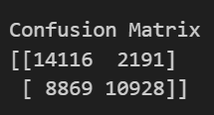
Performance Metrics:
Accuracy: 69.37%
Precision: 83.30%
Recall: 55.20%
F1 Score: 66.40%
Interpretation:
The model demonstrates strong precision, indicating that most predicted delays are genuine. Although recall is moderate, the model successfully identifies a substantial portion of delayed deliveries and can serve as an early warning system.

Key Findings
- Delivery performance varies significantly across shipping modes.
- Certain regions exhibit consistently higher delay rates.
- Some countries contribute disproportionately to delayed deliveries.
- Actual shipping durations frequently exceed planned schedules.
- Monthly trends reveal fluctuations in delivery performance.
- Region and shipping mode combinations significantly influence delay risk.
- Machine learning can effectively predict high-risk deliveries.

Recommendations
- Improve logistics operations in high-risk regions.
- Monitor underperforming shipping modes closely.
- Establish early-warning systems for high-risk shipments.
- Review scheduling practices where actual delivery times exceed planned durations.
- Utilize predictive analytics to proactively manage delivery risks.
- Continuously monitor delivery performance using KPI dashboards.

Conclusion
This project successfully evaluated delivery performance using descriptive analytics and predictive modeling techniques.
The analysis identified important delivery patterns across shipping modes, regions, countries, and time periods. Furthermore, the machine learning model demonstrated the ability to predict late delivery risk with reasonable accuracy.
The findings provide valuable insights for improving delivery reliability, enhancing customer satisfaction, and supporting data-driven supply chain decision-making.

